**Activity 2: AWS Elastic Beanstalk**

Brandon Trinkle

Information Technology, Arizona State University

IFT 320: Class Name

Professor Rahul Kashyap

9/15/2024

**Activity 2: AWS Elastic Beanstalk**

**Figure 1**

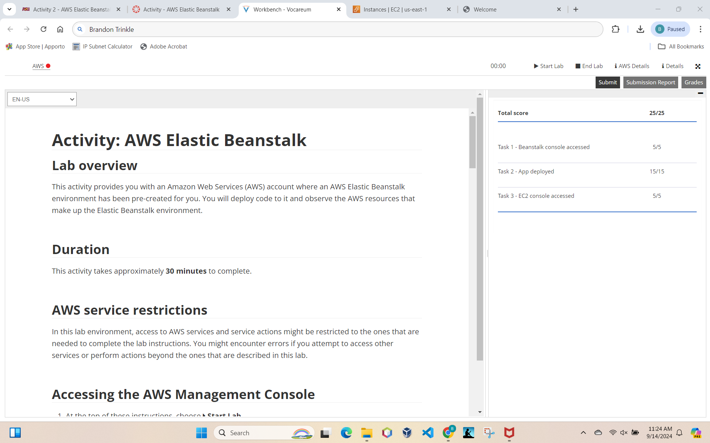

*Note*. AWS Activity 2 result, name included in URL.